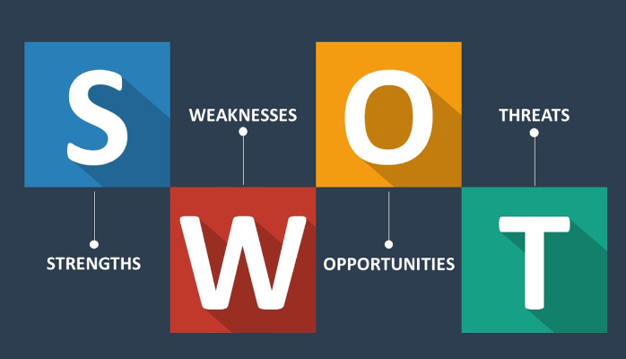

Use the following questions to support you in conducting a self SWOT analysis:

**Strengths (don’t be modest):**

* How do your education, skills, talents, certifications, and connections / networks set you apart from your peers?
* What would your boss or coworkers say are your strengths?
* What resources do you have at your disposal?
* What contributed the most to your past victories?
* What values or ethics do you have that your peers often lack?
* What achievements are you most proud of?

**Weaknesses (be honest):**

* Where are your education, training, or skills lacking? What’s missing and needs improvement?
* What would your boss or coworkers say are your weaknesses or areas of improvement?
* What are your negative work habits and personality traits?  
   What do you avoid because you lack confidence?

**Opportunities:**

* Which opportunities are you not exploiting at the moment?
* What trends are affecting your industry – the industry you belong to or wish to be in?
* In what areas is your industry growing?
* How could new technology help you advance?
* How could your connections and networks help you?

**Threats:**

* What obstacles do you currently face in your career and life?
* Who is your competition?
* Will new technology or certifications demands slow your progress in achieving your goals?
* How is your job or industry changing in ways that could affect your advancement?

S.W.O.T

|  |  |
| --- | --- |
| Strengths   * Enable to use computer basics. * Time keeping * Manage to make personal decision * Evaluating myself * My guardian. | Weaknesses   * Asking question in class * Slow when typing * Careless about group discussion. |
| Opportunities   * Upcoming coding and programing languages * Exposure to same field with others * Job creating skill * Use internet to know about real life | Threats   * Competition in tech space. * New invention that I might not with conversant with * world unfair; gender |